## Task:

* Install Git on your computer (if it is not already installed). You can download it from the official website at <https://git-scm.com/downloads>

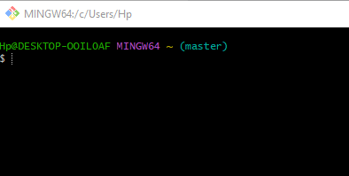

* Create a free account on GitHub (if you don't already have one). You can sign up at <https://github.com/>

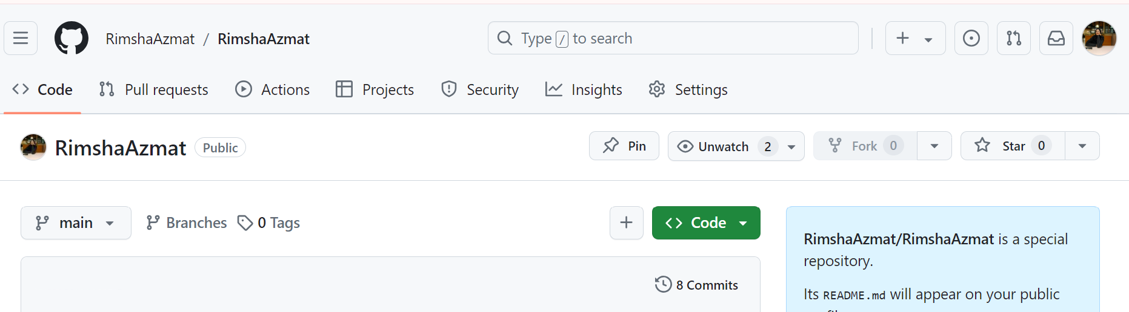

**Exercise**

* Clone the remote repo

[https://github.com/aqeelanwar/Tic-Tac-Toe](https://github.com/aqeelanwar/Tic-Tac-Toe" \t "_blank)

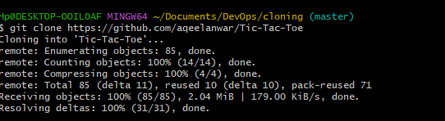

* This may be setup with the master branch instead of the main
* Check the branches in git to verify
* Update the last two commands with the appropriate branch name

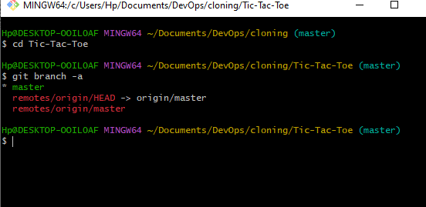

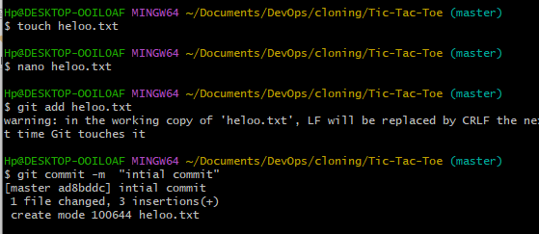

* Create a private repo on your GitHub account called Tic-Tac-Toe
* Set the remote origin with your new repo clone URL
  + git remote set-url origin https://github.com/XXXXX-USERID-XXXXX/Tic-Tac-Toe.git

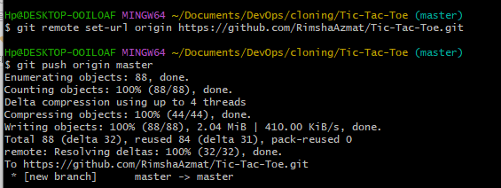

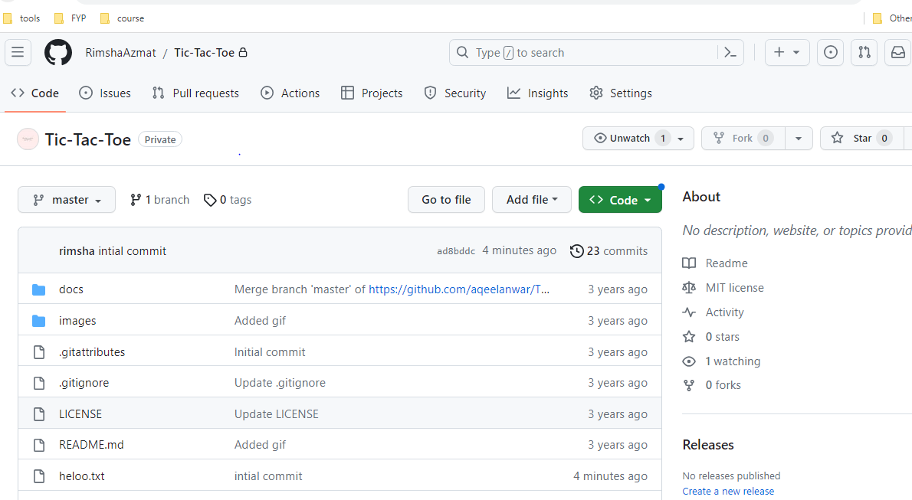

* Run the following commands to push your local repo to GitHub
  + git branch -M main
  + git push -u origin main

